- Abstract
- Introduction
  - More for pufa or temperature or both?
  - Main focus: cold adaptation
  - Mention pufas too as a relevant biological thing
- Materials and Methods

From Serina: Looking great so far! In general, I just changed details (see comments). Overall don’t worry about putting in the references right now. If you’re running short on time those can always be added in later (even this fall). Priority is getting the results down in writing while they’re fresh in your mind. If you have time (e.g. after you’ve got a results draft) I would consider breaking the methods and results up into sub-headings like ‘Machine learning,’ ‘Phylogenetics’ etc. to break up the text a bit. Nice job, I know you’ve been working hard!

Literature was searched to acquire optimum growth temperature and isolation information for the 20 psychrophiles and thermophiles from which OleAs were ordered. Optimal growth temperature was also found for many of the 73 organisms with OleAs from previous experiments in the Wackett lab.
The Shewanella putrefaciens OleABCD amino acid sequences and the PfaA sequence from Shewanella oneidensis were blasted against the proteome of the 20 psychrophiles and thermophiles. Hits with greater than 25% identity and 75% query cover were considered true hits. Phylogenetic trees were built with MEGA X software using ClustalW, the maximum-likelihood method, and 500 bootstraps. The gene diagram was formed from the blast hits described earlier, centered on the oleA and removing any relevant genes farther than 12,000 bp away.
Global protein properties like hydrophobicity, instability index, and isoelectric point were calculated in R using the Peptides package (include reference to sheet with descriptions?). Ratios between specific residues, including specifically relevant ratios like RKrat, were calculated.
Sets of residues from specific protein features were extracted in R. These features included channels A and B from the Xanthomonas campestris 4KU5 structure (Goblirsch et al. 2016) and spheres of varying radii (in Å) away from the alpha carbon of the active site cysteine (C143). Five physiochemical properties were calculated for each residue ().
Machine learning prediction of temperature optimum was done with the random forest algorithm in the ‘ranger’ package in R. Forests were grown to a size of 500 trees. Features with near-zero variance were removed using the nearZeroVar function from the caret package in R (). Data was split randomly with 80% going into the training set and 20% into the testing set. The models were built using the ‘train’ function in the ‘caret’ package. Residue factors that were shown to be significant in the prediction were found using the varImp function of the ranger package.
Machine learning was used to predict optimal temperature using random forest regression. Four different feature sets were tested and compared: channel residues, 8 angstrom sphere, 10 angstrom sphere, and 12 angstrom sphere. Root mean squared error and r squared error were used to assess performance.
A machine learning model was also made to categorize the samples into 3 groups of different temperature ranges: equal to or less than 15 °C, greater than 15 °C and less than 30 °C, and equal to or greater than 30 °C. Classification accuracy of the training 10-fold cross validation and classification accuracy for the prediction of the testing set as well as standard deviation for each set were used to assess performance.

  - Lit searching
  - Searched for pufa genes
  - Made gene diagrams/phylogenetic trees
    - Mega info
    - Define what a “hit” is for diagram (75/20)
  - Calculated global protein properties and protein ratios
    - Example in robinson journal article in writeup (reference supp. table in that)
  - Did machine learning with global properties
    - Random forest
    - Also examples in that paper
  - Extracted residues from specific feature sets
  - Did machine learning with feature sets (categorical and regression) to predict optimal temperature
  - Results: at important residues for prediction and formed possible experiments using mutant library and others
- Results
The dataset includes 30 OleAs from metagenome-assembled genomes (MAGs) acquired in the TARA Oceans expedition, 20 OleAs from psychrophiles and thermophiles isolated from extreme conditions, and 73 OleAs used in previous experiments in the Wackett lab (). The 20 OleAs from extreme conditions are a taxonomically and isolation representative subset of a larger group of 200+ OleA-type clusters.
Figure 1. Phylogenetic tree and oleABCD gene localization in 20 strains isolated from extreme temperature conditions. Bootstrap thing. Blue labels signify psychrophilic organisms (optimal growth temperature < 15 °C), purple labels signify mesophilic organisms (15 – 40 °C), red labels signify thermophilic organisms (> 40 °C), and black labels have no temperature information. Blast hits greater than 12,000 bp from the oleA were removed from the diagram for clarity.

Many of the ordered sequences were shown to have multiple hits from the ole cluster, but only a few had the genes in the classical order oleABCD: Moritella sp. JT01, Deltaproteobacteria strain B9_G4, and Epsilonproteobacteria strain B11_G4. Kocuria salsicia sp. G1 has a unique oleABC fusion, while Salinibacterium sp. UTAS2018 and Paeniglutamicibacter gangotriensis strain ANT_H27 have oleBC fusions. No significant hits were found for pfaA in the 20 psychrophiles and thermophiles, but there were known hits in the TARA Oceans MAGs.
Paragraph about global protein props/whats worth it?
Random forest regression was used to determine which feature set provided the best prediction of optimal temperature. The channel residues with a 0.8 training/testing split showed the best prediction. 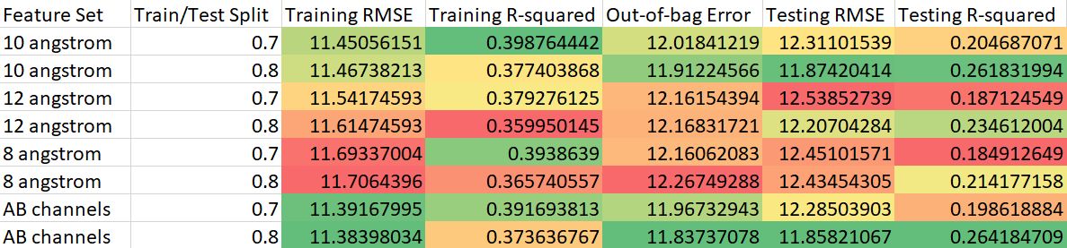
Categorical random forest was used to determine which temperature thresholds the algorithm could best predict using the channel residues. The algorithm was able to sort the sequences best into 2 groups: > 30 °C and < 15 °C. 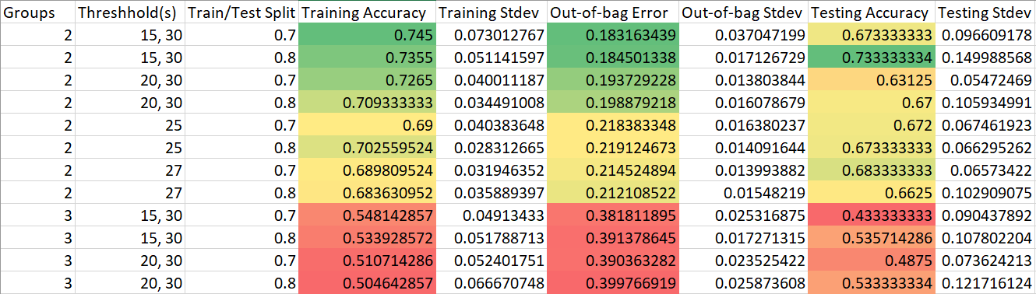
There were certain variables that were more significant in prediction than others. (attach sheet of specific properties for each important residue?) These residues aligned in Xanthomonas campestris are S112, T172, V176, L203, I258, I284, H291, T292.

  - Introduce dataset (multipanel figure and supplemental table)
    - Over 200 olea-type clusters and picked taxonomically diverse strains
  - Tree/diagram
  - Heatmap (supp?) worth mentioning RKrat
  - Machine learning stuff
  - Tables with feature sets
  - Important residues
- Future directions/planned experiments
Future work will be done to investigate the activity/functionality of the oleABC fusion in Kocuria salsicia sp. G1. Several sections of the gene fusion have been ordered and transformed in E. coli. These peptides can be screened for activity using a pNP assay to determine if this unique fusion is an evolutionary event that does not hinder activity or if it leaves the protein non-functional.
More work can be done with the important channel residues and their correlation to temperature preference. The Wackett lab has a library of Xanthemonas campestris mutants with a number of point mutations with these important residues. Various mutants can be screened at multiple temperatures and activities will be compared.
Some of these strains from the 20 psychrophiles and thermophiles can be ordered and grown at their optimum temperature. This would allow the observation of natural substrates in the organism, such as more or less unsaturated fatty acids in pfaA-containing genomes. The activity of the OleAs from these organisms could also be compared at multiple temperatures to determine if organism optimal growth temperature correlated heavily with peak activity temperature for the enzyme.
  - Kocuria funny business
  - Mutant library screening for important channel residues
  - Activity assays?
- Figures
  - Figures describing dataset
  - Feature analysis
    - Channel logo A
    - Channel logo B
    - There are more of these
  - Machine learning
    - Logo of important residues in channel for temperature prediction
    - Example temperature prediction plot

